1. General

1.1 Purpose: The purpose of this standard operating guideline is to provide guidelines for the District Duty Chief.

1.2 Scope: This standard operating guideline applies to all duty personnel of Yakima County Fire District 12.

1.3 Enforcement. Enforcement of this standard operating guideline is the responsibility of the District’s Chief Officers. Any person deviating from the provisions of this guideline may be required, at the discretion of the Chief’s, to submit in writing, within five (5) calendar days, an explanation for such deviation to the requesting officer who will forward the explanation up the chain of command for further review.

2. Definitions

2.1 “Duty Chief”: This position is covered by the Chief, Deputy Chief, Captains, Lieutenants, and Firefighters qualified. Duty Chief coverage is 365 days/year signed up in the Google Calendar.
2.2 “Duty Chief Trainee”: The Duty Chief Trainee has an open Duty Chief task book and serves as a Duty Officer under the Duty Chief. Duty Chief Trainees sign up for available weekends through the Google Calendar. Duty Chief Trainee is a weekend position and special circumstances.

3. Duty Chief Responsibilities Each Week

3.1 Obtain a pass-a-long from outgoing Duty Chief regarding equipment status, schedules, events etc.
  - Be available by cell phone.
  - Send Duty Sheet to Valley Fire or ensure it has been completed by staff.
  - E-mail “Weekend Update” to all personnel or ensure it has been completed by staff.
3.5 Contact Trainee (if there is one signed up) for weekend schedule.
  - Be available 24 hours a day unless a Trainee is covering you, or you plan with another officer for coverage. When doing duty with a Trainee the Duty Chief is responsible for monitoring and signing off the Trainee.
  - Check with Training Officer for which Wednesday night drill your attendance is needed at.
  - Monitor WV incident radio traffic until completion of incident.
  - Perform command car check, check medical equipment, SCBA, PASS, place accountability tags on passport and helmet shield on helmets, test on board equipment and radios.
  - Read e-mail daily.
  - Keep Pager and duty cell phone on 24 hours a day. (pager in alert mode)
  - If you are driving by a station pull in and do a security check (doors locked, lights off etc.). Pick up riders and equipment from the hospital.

4. Alarm Response

4.1 Respond to multi-apparatus alarms, unusual circumstances, anytime requested by on scene crews, and mutual aid command response requests.
  - Respond at the appropriate level (code I, II, or III) to the alarm you are responding to.
4.3 Trainee responds as “Duty Fifty”, Duty Chief responds with “Battalion 50”, Administrative Staff responds with their assigned designator.
4.4 When a Trainee is on duty, only the Duty Chief or Trainee responds out of District not both.
  - After an alarm, ensure all equipment is placed back in service and all paperwork is properly completed.

5. Events

5.1 Check the schedule of events and attend events (pub-ed, community events) when available, the Duty Officer/Chief whenever possible should be “signed up” to help for events occurring during their duty and attend drill.

6. Trainee Compensation

6.1 Trainees will be compensated with a standby stipend of $3.50 per hour, plus their regular rate for each alarm/event attended.
6.2 Trainee shifts are typically weekends, Friday night until Sunday night or Monday morning determined in conjunction with the Duty Chief.
6.3 Trainees are responsible to document all activities on the “Duty Officer Log” and make every effort to be on each call roster. Duty Logs must be turned in either to Admin or the gray Station Report Box during the week following duty.
  - Holidays: There is no extra compensation for doing duty on a holiday.
6.5 At the discretion of the Duty Chief, when we are shorthanded in personnel the Duty Chief may elect to bring on a Trainee during the regular work week, on a case-by-case basis.

7. Duty Chief Compensation:

  - On-Call members serving as Duty Chief are compensated a standby stipend of $4.25/hour of coverage plus their regular rate for each alarm/event attended. Stipends are paid by clocking in and out on your Duty Sheet, alarms and events also must be documented on your duty sheet for compensation.
- Holidays: There is no extra compensation for doing duty on a holiday.
  - A normal duty shift for the Duty Chief is Thursday 17:00 to next Thursday 17:00. On-Call Members may serve as Duty Chief for a shorter duration such as covering weeknights or weekends.
  - Administrative Duty Chiefs will be compensated with the first regular workday following their duty shift as a day off (Friday). Administrative Duty Chiefs may end up with mixed days in a week of duty, once they accumulate 7 nights of duty, they receive one day off. At the end of the duty shift Thursday at 17:00 the Duty Chief is relieved by the on-coming Duty Chief after a face-to-face meeting.
- Use it or lose it: The Admin Duty Chief cannot bank duty days for future use, the day they get off duty is the day they can take off with exception: If for unforeseen reasons (meetings, apparatus issues, operational issues, something out of the Duty Chiefs control) the day can be traded for the next available day. Duty Chiefs should wherever possible make every attempt to use their duty day on the assigned day off or as much of that day off as possible.
- Holidays: Admin Duty Chiefs do not receive any further days off due to being on duty over a holiday, the regular duty Friday will be the day off for any given week. If a holiday day off occurs on your duty day off, you may take that holiday at your next available convenience (you get your duty day and a holiday day off).

8. Policy 2405 “Command Vehicle Use”:
  - Personnel may use vehicles for incidental personal trips and business when necessary to maintain a state of readiness to enable such personnel to provide emergency response 24/7.
  - Passengers: When responding to emergencies in code 3 mode, vehicles shall be occupied by District personnel only. When responding in non-emergency mode, code 1 or 2, the vehicle may be used to carry non- District personnel as passengers when incidental to the trip or when required by the needs of the driver when on stand-by status (only to happen when they were already riding with you for an incidental trip, do not pick them up or bring them from home to a call).

  - Return Duty Vehicle to Admin full of fuel in clean working order and report any deficiencies to the oncoming Duty Chief and submit a work request for deficiency.

Yakima County Fire District 12
West Valley Fire Department

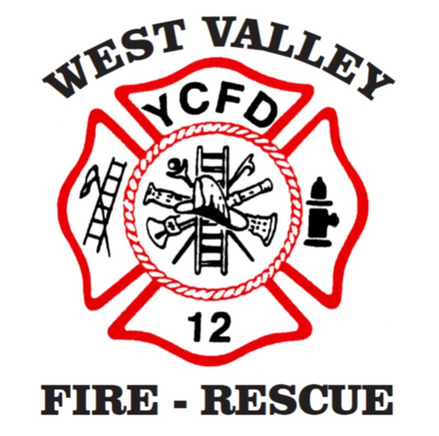
Duty Chief Trainee Task Book

“Dedicated to the preservation and protection of life, then property”

Duty Chief Trainee Task Book
This task book contains the competencies, tasks, and evaluations required for a member to complete the Duty Chief Trainee program. Successful completion and final Chief Officer approval are required before a member may function as Duty Chief.

Trainee Information
Trainee Name
Rank/Position
Start Date
Completion Date

Instructions for Use
1. Each task must be performed and evaluated by a qualified Duty Chief.
2. Evaluators must initial and date each completed task.
3. The trainee is responsible for maintaining this task book and ensuring all tasks are completed.
4. Upon completion, the task book will be submitted to the Deputy Chief for final review.

Experience, and Certification Requirements
Exp or Cert | Evaluator Initials/Date
Valid Driver’s License
ICS 100, 200, 700, 800
I-300
NFA Tactics/Command class
Instructor I
Wildland FF I
Incident Safety Officer
S-215 or wildland interface course.
5 Years WVFD Experience
Officer Development Course
Completed a fire report accurately.

Administrative
Task | Evaluator Initials/Date | Evaluator Name/Title
Demonstrate understanding of Duty Chief SOG and responsibilities.
Complete required administrative reports and documentation.
Complete duty chief paperwork.

Incident Command
Task | Evaluator Initials/Date | Evaluator Name/Title
Establish Incident Command in accordance with NIMS/ICS.
Conduct size-up and provide initial incident report.
Request and manage additional resources as needed.
Transition command to higher authority when appropriate.

Operations & Resource Management
Task | Evaluator Initials/Date | Evaluator Name/Title
Coordinate mutual aid or automatic aid responses.
Monitor and manage incident safety until relieved by ISO.
Direct resource deployment during multiple company incidents.

Planning & Documentation
Task | Evaluator Initials/Date
Review two pre-incident plans for target hazards and report on strategy and water supply needs.
Demonstrate ability to conduct an after-action review.
Demonstrate ability to forecast staffing/resource needs for incident types.

Community & Public Interaction
Task | Evaluator Initials/Date | Evaluator Name/Title
Serve as Duty Chief point of contact for public inquiries.
Participate in community event or public education activity.
Interact professionally with law enforcement, EMS, and partner agencies.

Program Completion
Task | Evaluator Initials/Date
All tasks completed and signed off by evaluators.
Final review and recommendation by supervisor.
Meets Policy 2110.
Deputy Chief approval for Duty Chief status.

